Leadership Alamosa Sponsorship Opportunities
*Sponsorships will have visibility on printed signage, fliers, and website for the entire year*

2024 Program Sponsorship Level I: $1,500
- Name and Large Logo on the program as a sponsor. Includes all virtual advertising and printed materials, verbal thank you at each session, click through logos/links on program section of Website and mention in press release.
- Mid-sized logo displayed at each session on Thank You board

2024 Program Sponsorship Level II: $750
- Name and Medium-sized Logo on the program as a sponsor. Includes all virtual advertising and printed materials, verbal thank you at each session, click through logos/links on program section of Website and mention in press release.
- Small logo displayed at each session on Thank You board

2024 Program Sponsorship Level III: $450
- Name and Small Logo on the program as a sponsor. Includes all virtual advertising and printed materials, verbal thank you at each session, click through logos/links on program section of Website and mention in press release.

2024 Program Sponsorship Level IV: $250
- Name on the program as a sponsor. Includes all virtual advertising and printed materials, verbal thank you at each session.

Meal Sponsorships:
- Meal Sponsorships are need for both AM snacks and Lunch for each session. Sponsor can cover just AM snacks, or lunches, and would be annual for all 9 sessions.
- Meal sponsors receive a thank you sign at the event with their name/logo alongside the refreshments, as well as verbal thank you at each session and mention on website for the program.

THANK YOU TO OUR PROGRAM FOUNDERS
*Founders do not need to sponsor again until their term is completed*

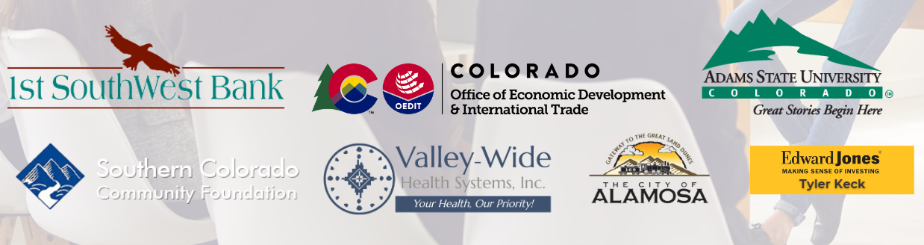

Sponsorship Commitment Form

Business/Organization Name: __________________________________

Email: ___________________________________

Phone: ________________________

Sponsorships:

2024 Program Sponsorship Level I: $1,500
2024 Program Sponsorship Level II: $750
2024 Program Sponsorship Level III: $450
2024 Program Sponsorship Level IV: $250
Meal Sponsorship, Amount: _________

Method of Payment: _________________________

Total Amount: _________________________

By signing this form, you are committing to Sponsorships chosen.

Printed Name: ____________________________

Signature: _______________________________

Date: ___________________________________

