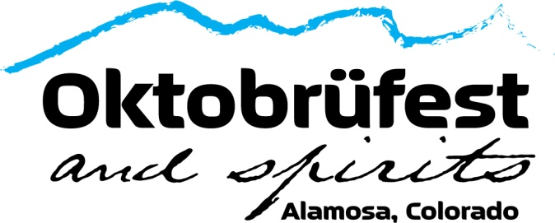

We are proud to announce the return of Oktobrüfest with our 2023 event!
This year’s event will be packed with many different breweries, distilleries & food vendors!
There will also be plenty of games for all ages, special appearances from The Salida Circus, contests, fun kid’s activities, and live music from “Four Letter Word”! This year’s date is Sept 23rd.

PILSNER LEVEL SPONSOR - $175
1 VIP package – Includes 2023 Swag, 1 VIP Wrist Band & Sample Acrylic Mug (Pick up at Event)
Website, Social Media, & other advertising with business name

PILSNER LEVEL SPONSOR - $325
2 VIP packages – Includes 2023 Swag, 2 VIP Wrist Bands & Sample Acrylic Mugs (Pick up at Event)
Website, Social Media, & other advertising with Small Business Logo
Business name announcement at the event

AMBER LEVEL SPONSOR - $575
4 VIP packages – Includes 2023 Swag, 4 VIP Wrist Bands & Sample Acrylic Mugs (Pick up at Event)
Banner placement at the event (please provide banner)
Website, Social Media, & other advertising with Mid-sized Business Logo
Business name announcement at the event

PORTER LEVEL SPONSOR - $850
6 VIP packages – Includes 2023 Swag, 6 VIP Wrist Bands & Sample Acrylic Mug (Pick up at Event)
Bonus Oktobrufest Swag Package for 6
Banner placement at the event (please provide banner)
Website, Social Media, & other advertising with Large Business Logo
Logo on Oktobrufest Event Webpage for an entire year!
Business name announcement 2x the event & Special Thank you at Chamber Luncheon

STOUT LEVEL SPONSOR - $1,500
8 VIP packages – Includes 2023 Swag, 8 VIP Wrist Bands & Sample Acrylic Mug (Pick up at Event)
Bonus Oktobrufest Swag Package for 8
Banner placement “Front and Center” on the stage (please provide banner)
Website, Social Media, & other advertising with Large Business Logo
*Pinned* thank you Post at the top of the event (1st thing everyone will see!)
Click-through Logo on Oktobrufest Event Webpage for an entire year!
Business name announcement 3x at the event & Special Thank you at 2 Chamber Luncheons

Business: ___________________________________ Contact Name: ___________________________________

Email: ___________________________________ Phone Number: ___________________________________

Signature: ___________________________________ Sponsorship Level: __________________ Date: _________

(Sponsorships are non-cancelable and non-refundable.)

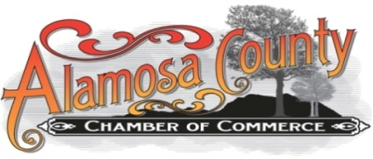
Forms and Checks can be dropped off at the Alamosa Chamber at 610 State Ave. or emailed to AlamosaCountyChamber@gmail.com *Make Checks payable to “Alamosa Chamber.”

