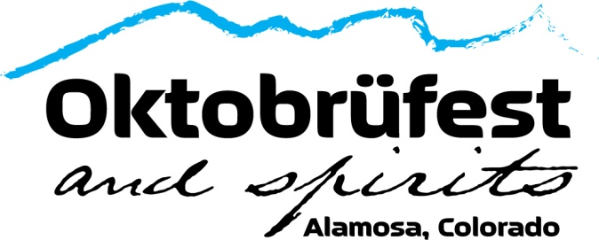

Vendor Application Form
This year’s event will be packed with many different breweries, distilleries & food vendors! There will also be plenty of games, contests, fun kid’s activities, and of course, live music!
If you are a vendor and are interested in participating, please fill out the below form.
All Chamber Members are able to participate as a vendor for free.

Business: ______________________________________________

Contact Name: _______________________________________

Email: ________________________________________________

Phone Number: _______________________________________

Description of Game/Activity/Food/Etc.:

Chamber Member:
YES: __________ ($25) NO: ___________ ($250 Flat Fee)

Do you carry your own Insurance /Food License):
YES: __________ NO: ___________

Date: _____________________

Forms and Checks can be dropped off at the Alamosa Chamber at 610 State Ave. or emailed to AlamosaCountyChambergmail.com *Make Checks payable to “Alamosa Chamber.”
We can also send a virtual invoice that can be paid Via Credit Card.
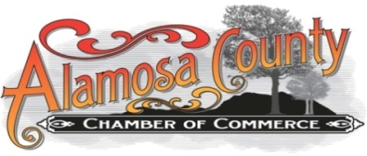
(Vendor fees are non-cancelable and non-refundable.)

